***Experiment 4***

**Inverter with 180 degrees conduction mode:(Circuit Diagram)**

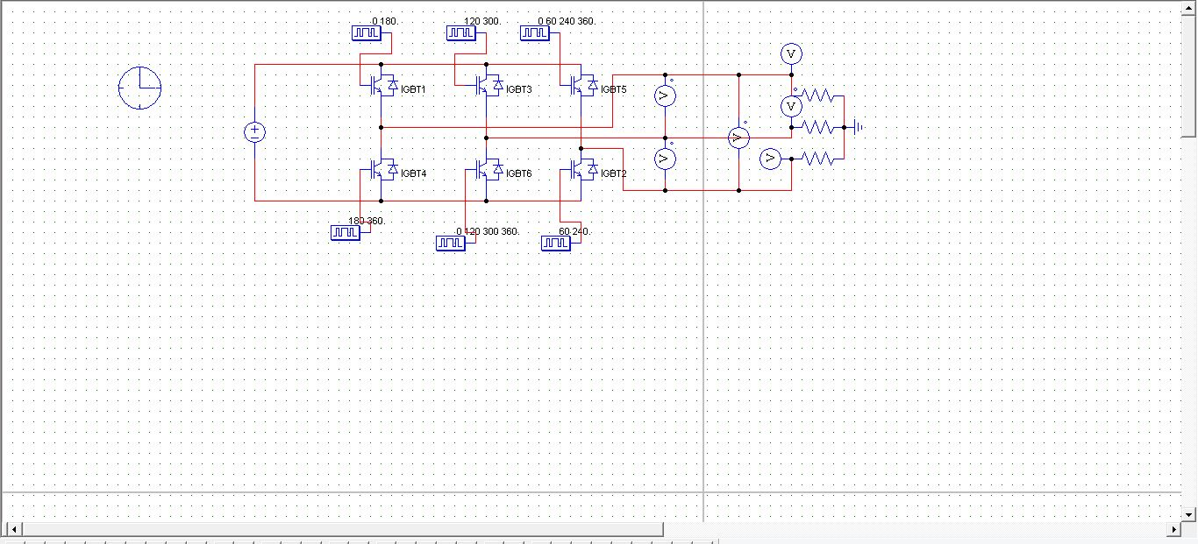

**Line Voltage Waveforms:**

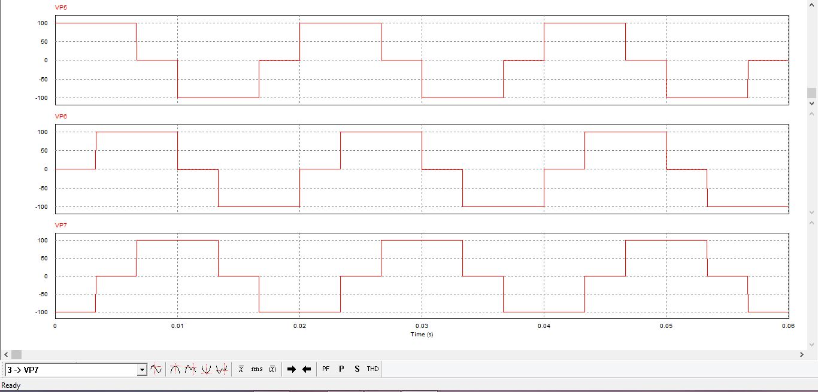

**Phase Voltage Waveforms:**

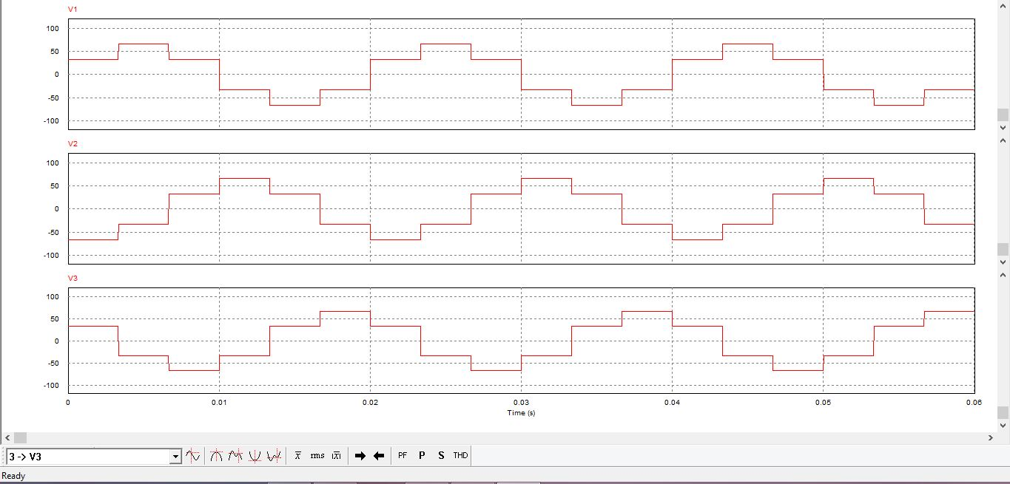

**__________________________________________________________**

**Inverter with 120 degree conduction Mode**

**Circuit Diagram:-**

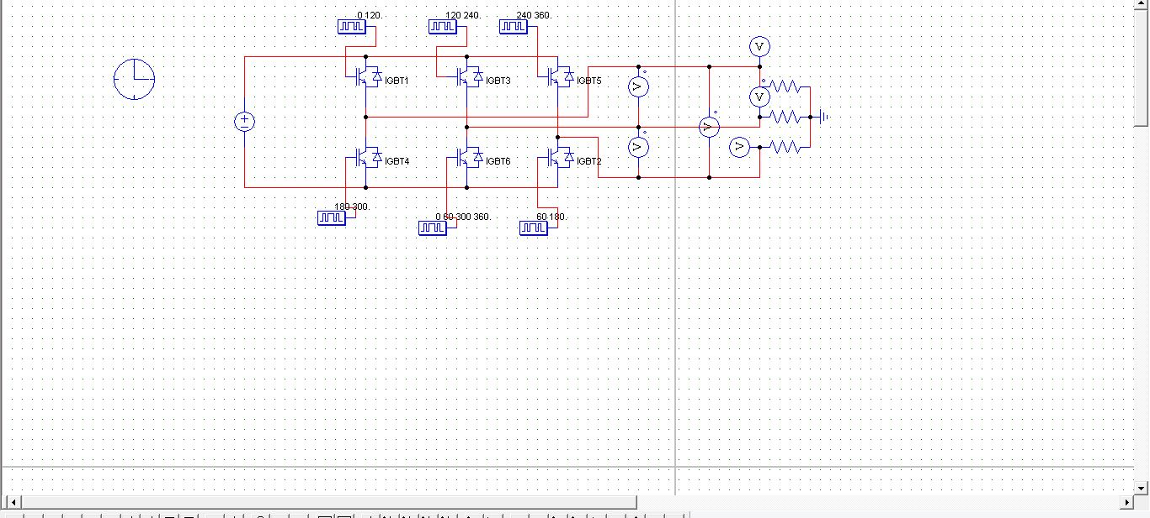

**Waveforms of Line Voltage:-**

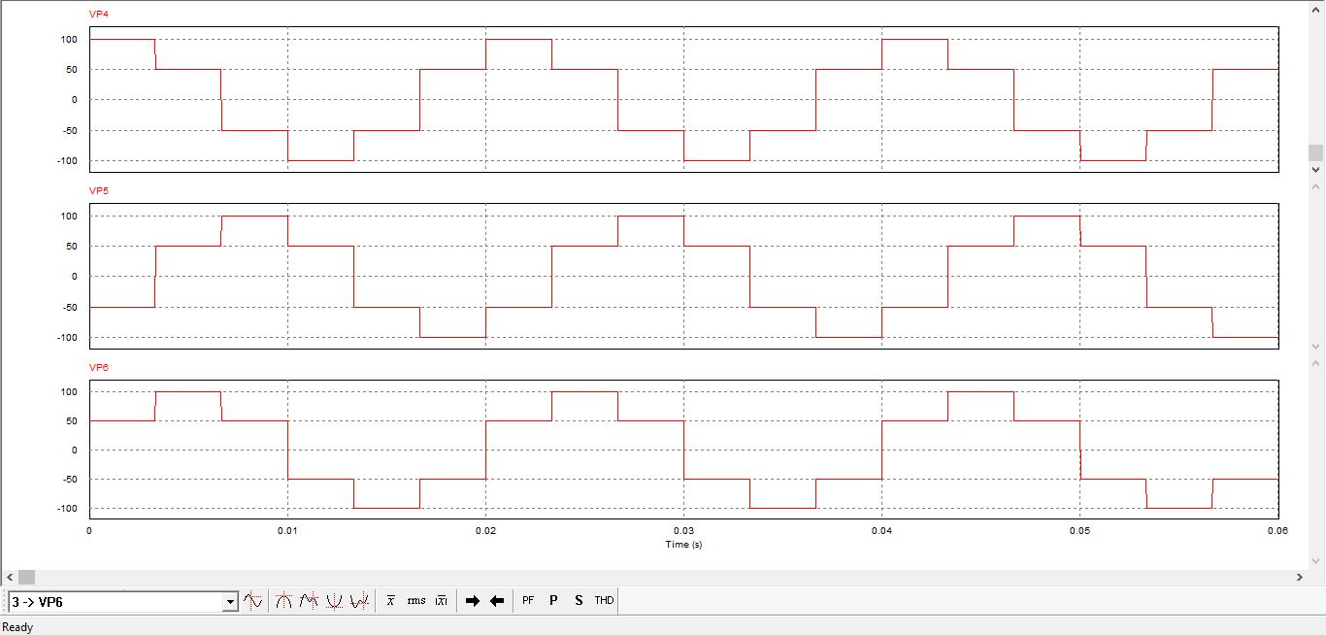

**Phase Voltage Waveforms:-**

